**Name : Ayush Kumar**

**Reg no : 21MCA1117**

**Lab Exercise on Packages**

**Date : 05-04-2022**

1. In a Manufacturing Unit, there are workers like Part-time workers and Full-Time workers. Write a superclass Total_workers and subclasses Part-timer Workers and Full-Time Workers. Every worker has a name, designation, number of hours worked and salary. Design a Parameterised method that computes the weekly pay for every worker. A Part-Time worker gets paid the hourly wage for the actual number of hours worked, if hours are at most 30. If the hourly worker worked more than 30 hours, the excess is paid at time and a half. The Full-Time worker gets paid the hourly wage for 50 hours, no matter what the actual number of hours is. Design a package that computes the pay of any worker. Apply suitable Java inheritance that executes these classes and methods.

**Code :**

**//File Name Total_Worker.java**

package worker;

import java.util.*;

public class TotalWorker{

public String name;

public String designation;

public Double hours;

public Double salary;

public TotalWorker(String n,String d,Double h){

this.name=n;

this.designation=d;

this.hours=h;

}

public void display(){

System.out.println("\n"+name+"\n"+designation+"\n"+hours+"\n"+salary);

}

}

**//File Name PartTime.java**

package worker;

import java.util.*;

import worker.FullTime;

public class PartTime extends TotalWorker{

PartTime(String n,String d,Double h){

super(n,d,h);

}

public void checkpay(double wage){

if(hours<30)

this.salary = hours*wage;

else

this.salary= hours*wage*1.5;

}

}

**//File Name FullTime.java**

package worker;

import java.util.*;

import worker.*;

public class FullTime extends TotalWorker{

FullTime(String n,String d,Double h){

super(n,d,h);

}

public void checkpay(Double wage){

this.salary=50*wage;

}

}

**//File Name Main.java**

package worker;

import java.util.*;

import worker.*;

public class Main{

public static void main(String [] args){

FullTime w1 = new FullTime("ram","manager",40.0);

w1.checkpay(300.0);

w1.display();

PartTime w2 = new PartTime("apurbo","sde",25.0);

w2.checkpay(300);

w2.display();

}

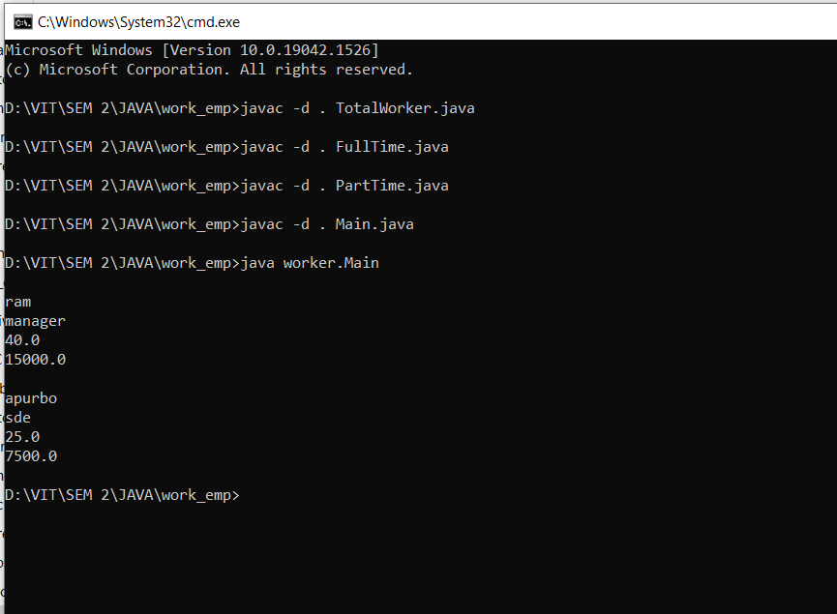}

2) Define a class Package1.Passenger with the following attributes: Name of the passenger, Street, town, state, pincode, age, source, and destination. Define a suitable constructor and a method for displaying details of the passenger. Define a class called Package2.Train with the following attributes: Train no, Starting point of travel, Destination of travel, date of Journey. Write java programs of accessing the details of a passenger travelling to a destination.

**Code :**

**//File Name** Passenger**.java**

package package1;

import java.util.*;

public class Passenger

{

public String name;

public String street;

public String town;

public int pincode;

public int age;

public String source;

public String destination;

public Passenger(String n,String s,String t,int pin,int a,String sou,String des)

{

this.name=n;

this.street=s;

this.town=t;

this.pincode=pin;

this.age=a;

this.source=sou;

this.destination=des;

}

public void display(){

System.out.println("\n"+name+"\n"+street+"\n"+town+"\n"+pincode+"\n"+age+"\n"+source+"\n"+destination);

}

}

**//File Name** Train**.java**

package package2;

import java.util.*;

public class Train{

public int no;

public String start;

public String end;

public String date;

public Train(int n,String s,String e,String d){

this.no=n;

this.start=s;

this.end=e;

this.date=d;

}

public void display(){

System.out.println("\n"+no+"\n"+start+"\n"+end+"\n"+date);

}

}

//File Name Main.java

package irctc;

import package1.Passenger;

import package2.Train;

public class Main{

public static void main(String [] args){

Passenger p1= new Passenger("joyraj","Ln street","Habra",743223,23,"kolkata","chennai");

p1.display();

Train t1 = new Train(200547,"Hawrah","MGR","5/4/2022");

t1.display();

}

}

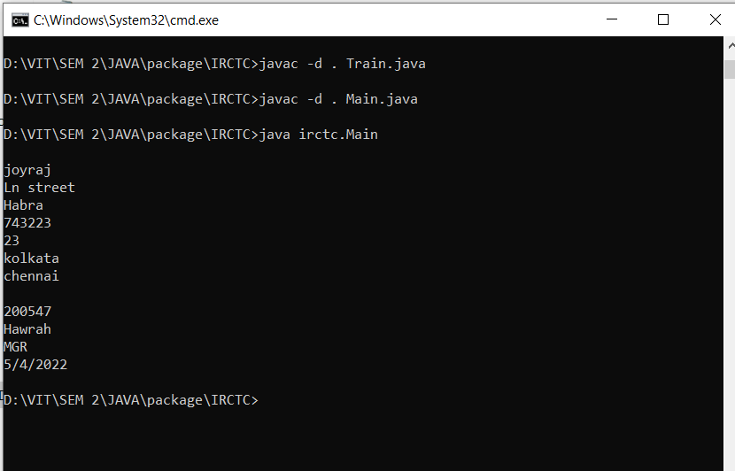**Output :**